Jatropha Oil Extraction Analysis Report

# 1. Regression Model Summary

R-squared: 0.5906

Adjusted R-squared: 0.1519

RMSE: 2.0827

MSE: 4.3377

# 2. Model Coefficients

|  |  |
| --- | --- |
| Term | Coefficient |
| 1 | 0.000000 |
| X1 | -1.014167 |
| X2 | 0.672500 |
| X3 | 0.512500 |
| X4 | 1.096667 |
| X1^2 | -0.178750 |
| X1 X2 | 0.278750 |
| X1 X3 | -1.400000 |
| X1 X4 | -1.690000 |
| X2^2 | 0.711250 |
| X2 X3 | 0.487500 |
| X2 X4 | 0.335000 |
| X3^2 | -0.672500 |
| X3 X4 | 0.276250 |
| X4^2 | -0.111250 |

# 3. Analysis of Variance (ANOVA)

|  |  |  |  |  |  |
| --- | --- | --- | --- | --- | --- |
| Source | SS | DF | MS | F-value | P-value |
| Regression | 187.7037 | 14 | 13.4074 | 1.5454 | 0.206358 |
| Residual | 130.1324 | 15 | 8.6755 |  |  |
| Total | 317.8361 | 29 |  |  |  |

# 4. Response Surface Plots

## 4.1 Moisture Content (%) vs Heating Temperature (°C)

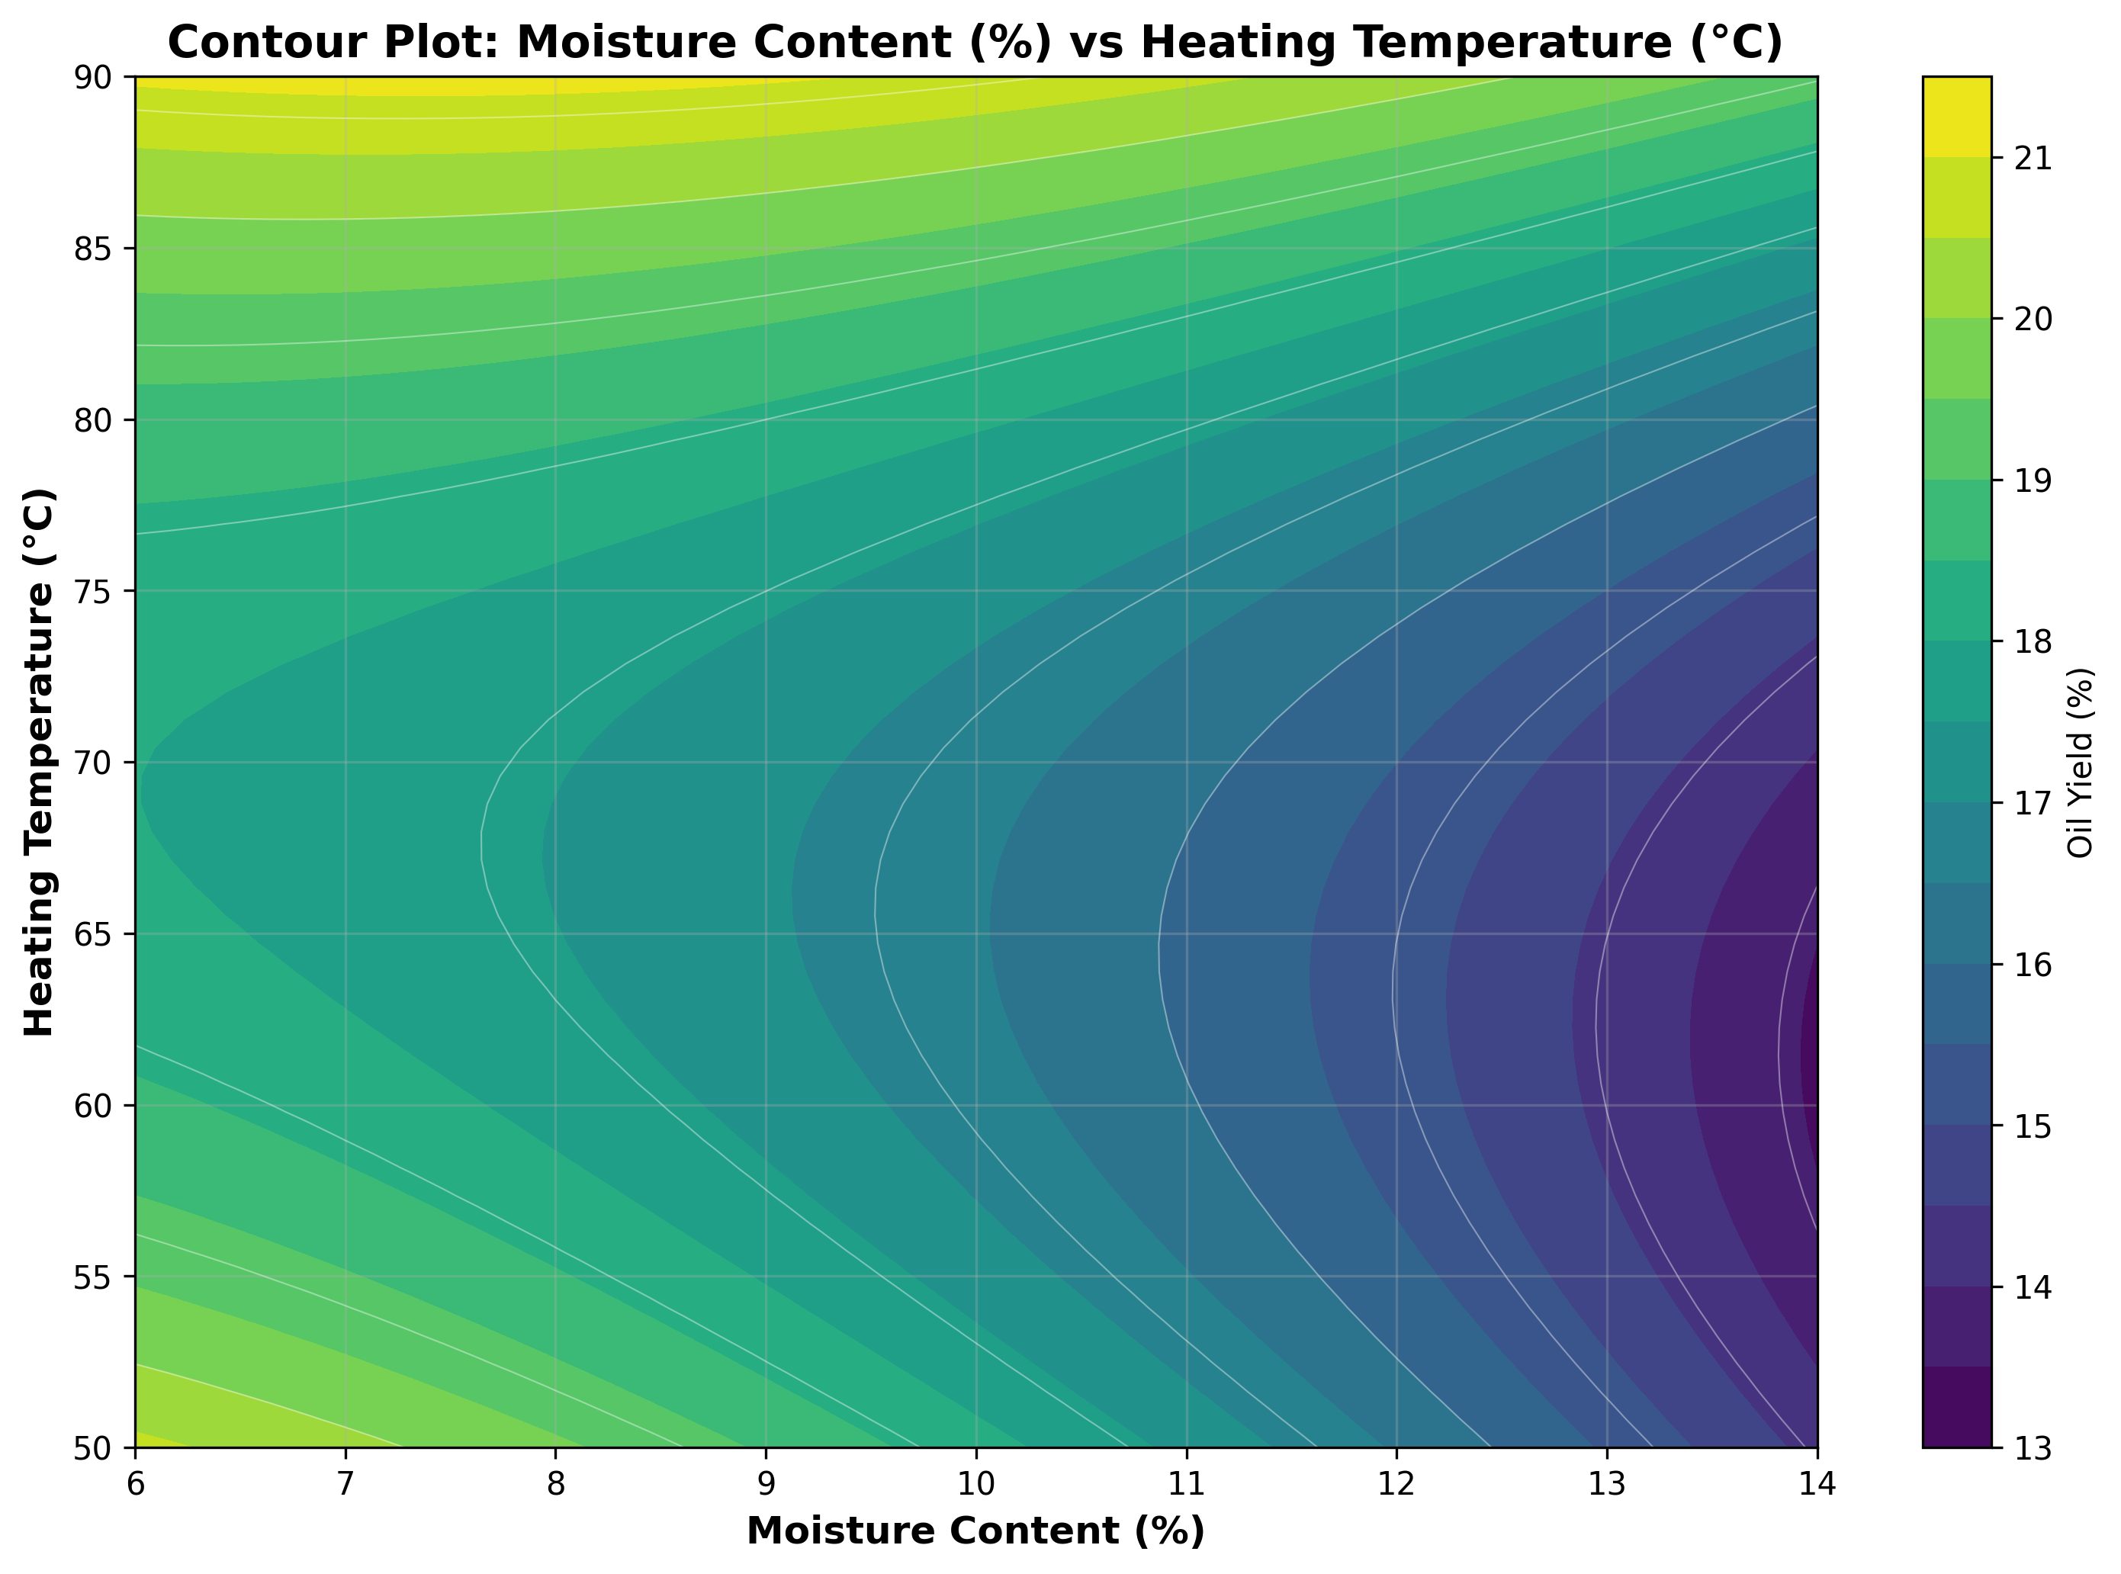

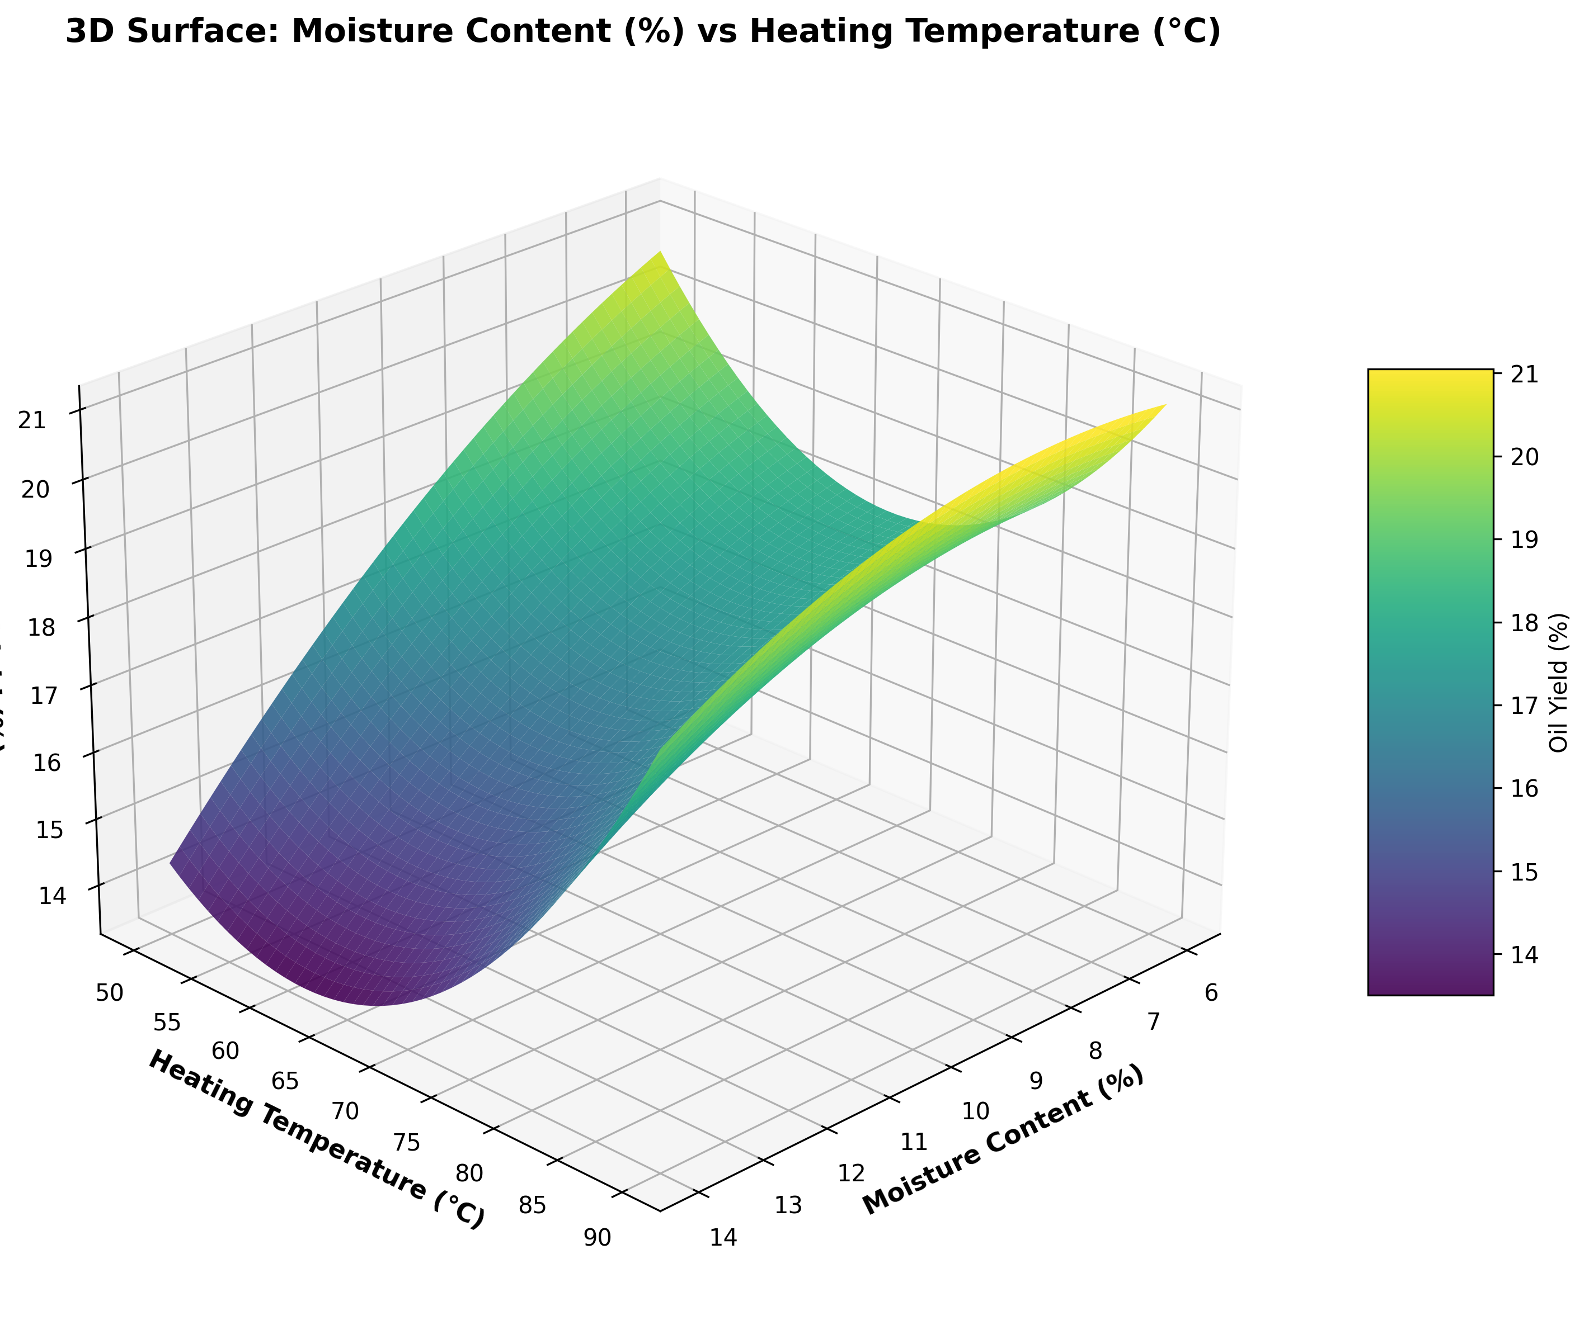

## 4.2 Moisture Content (%) vs Extraction Time (min)

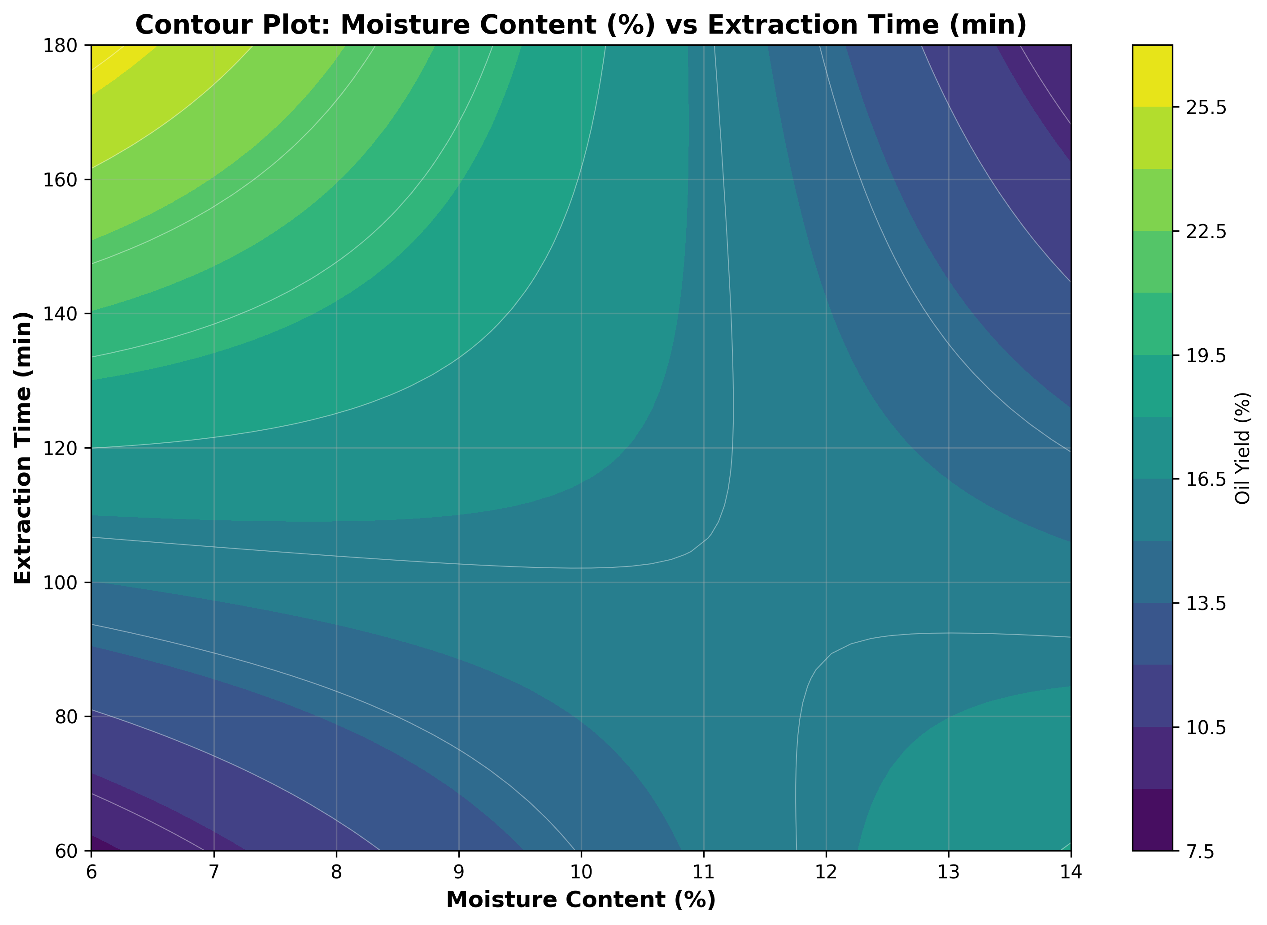

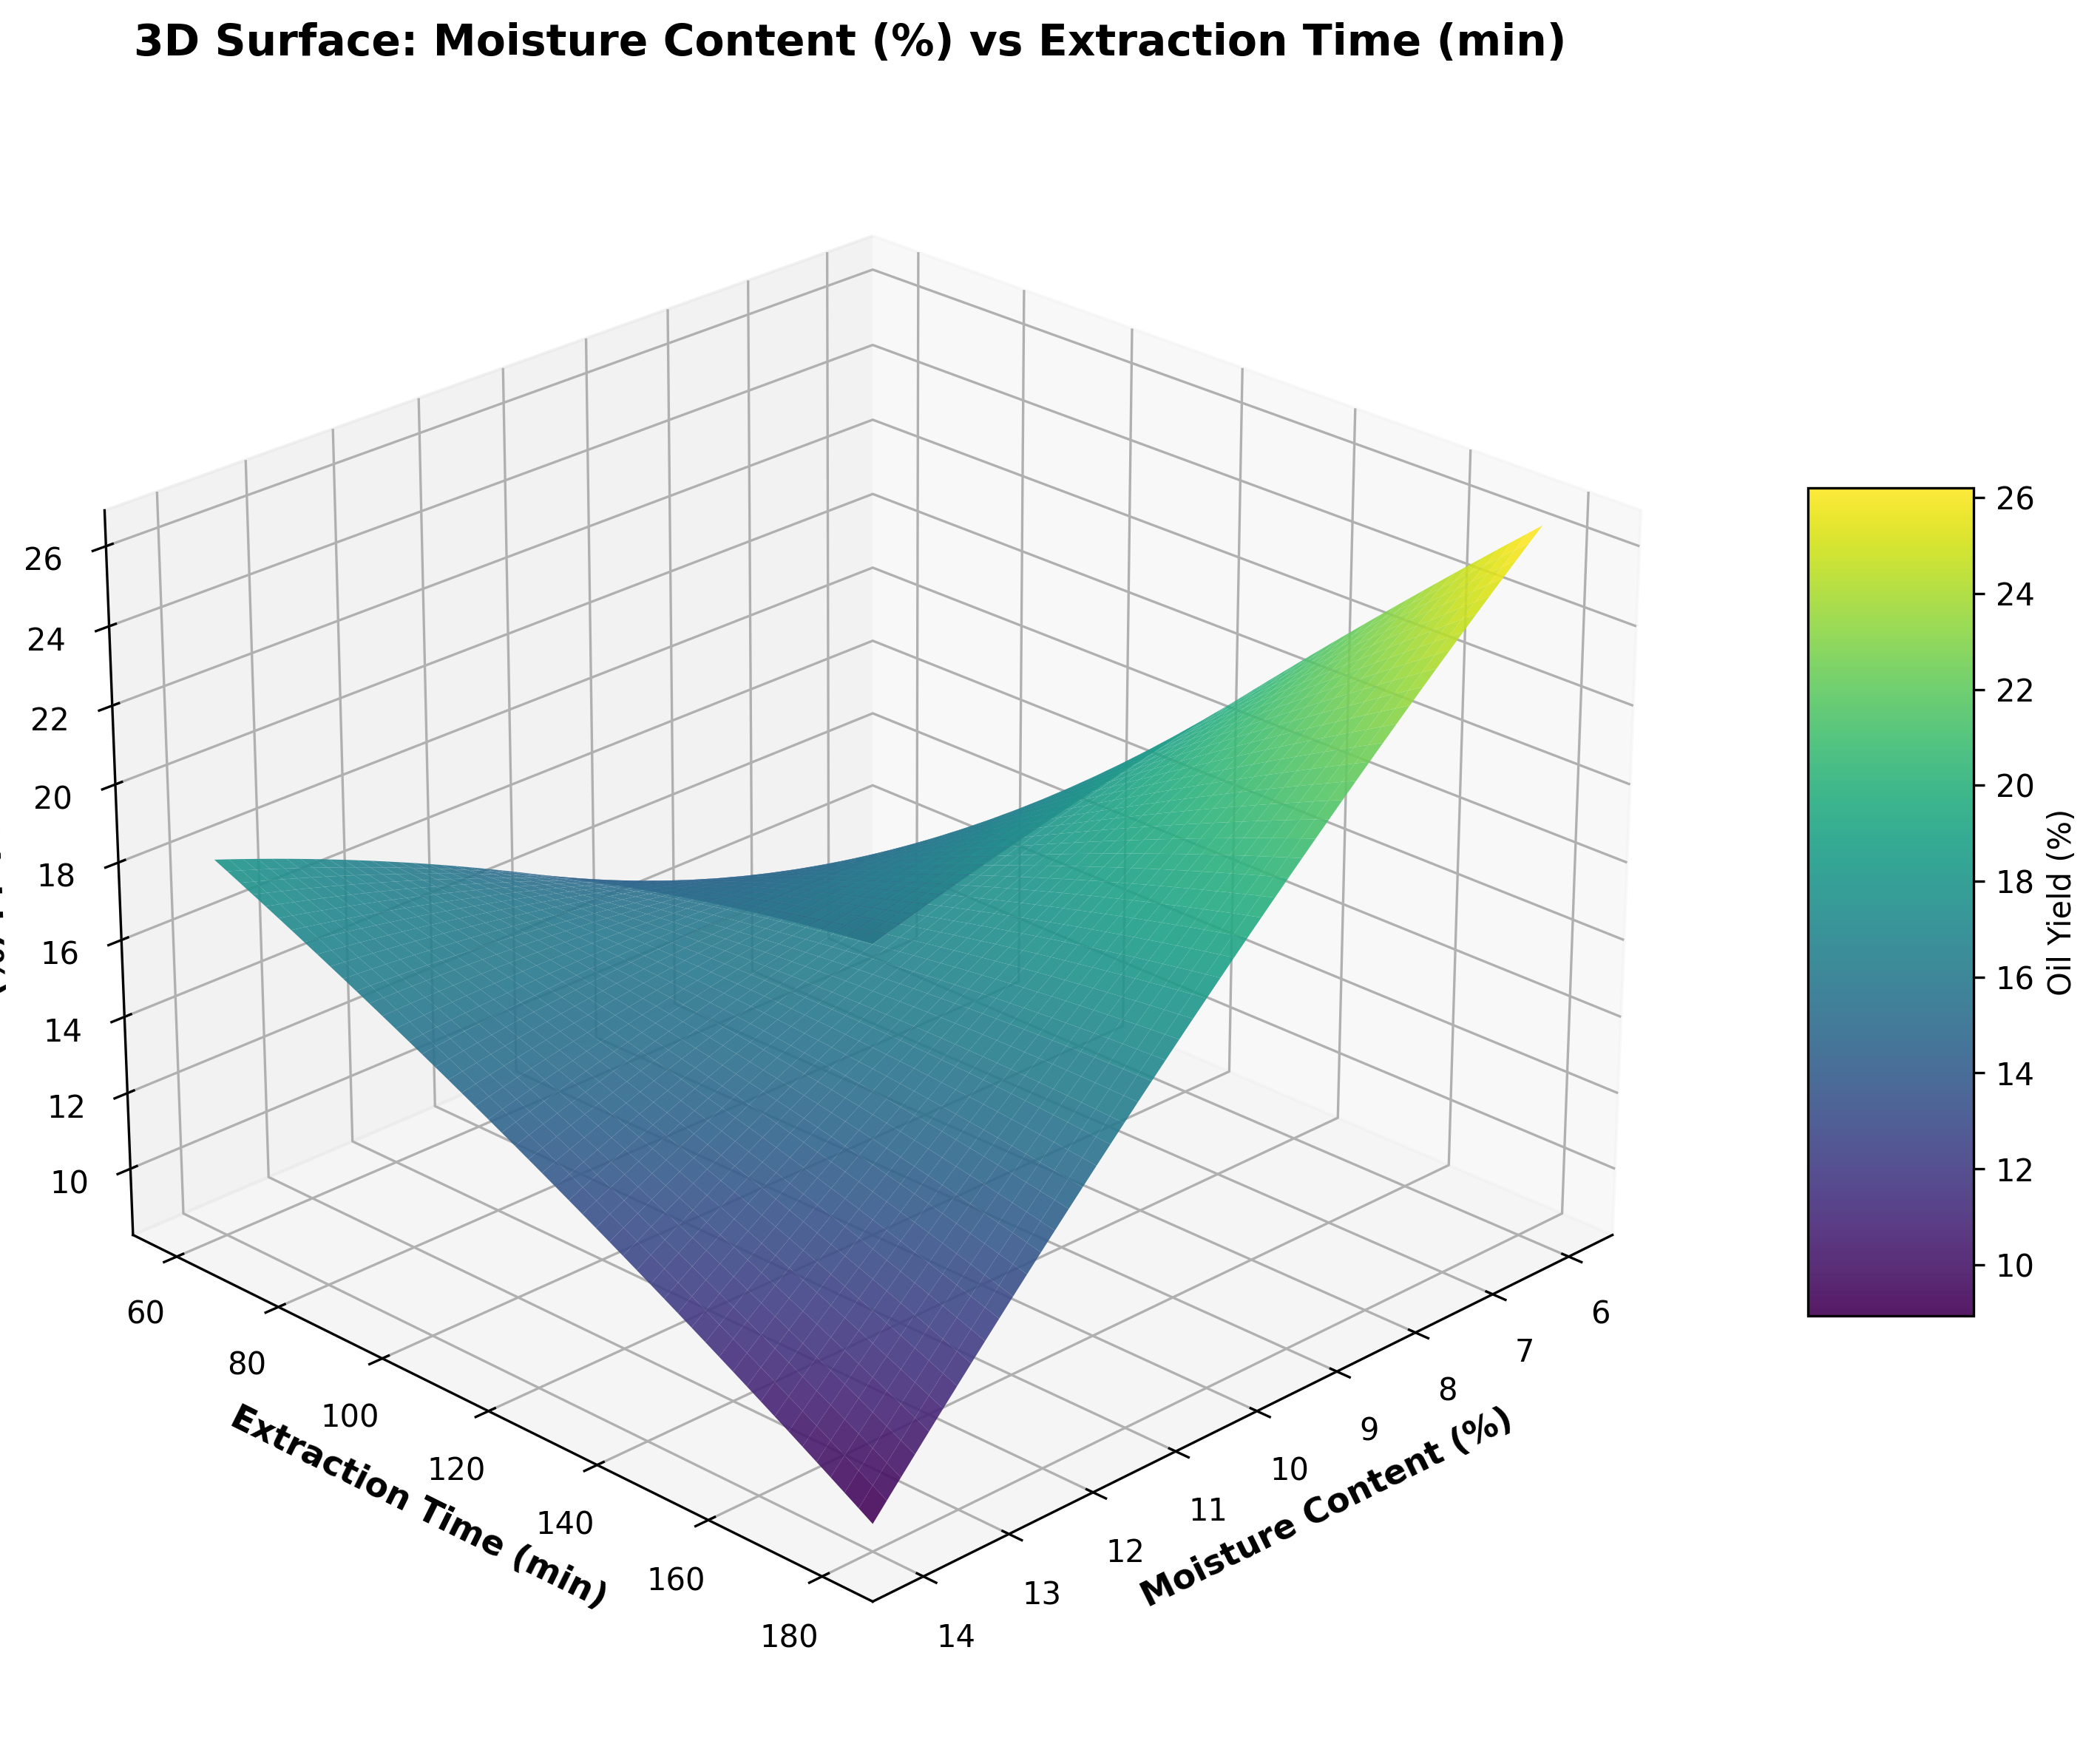

## 4.3 Heating Temperature (°C) vs Extraction Time (min)

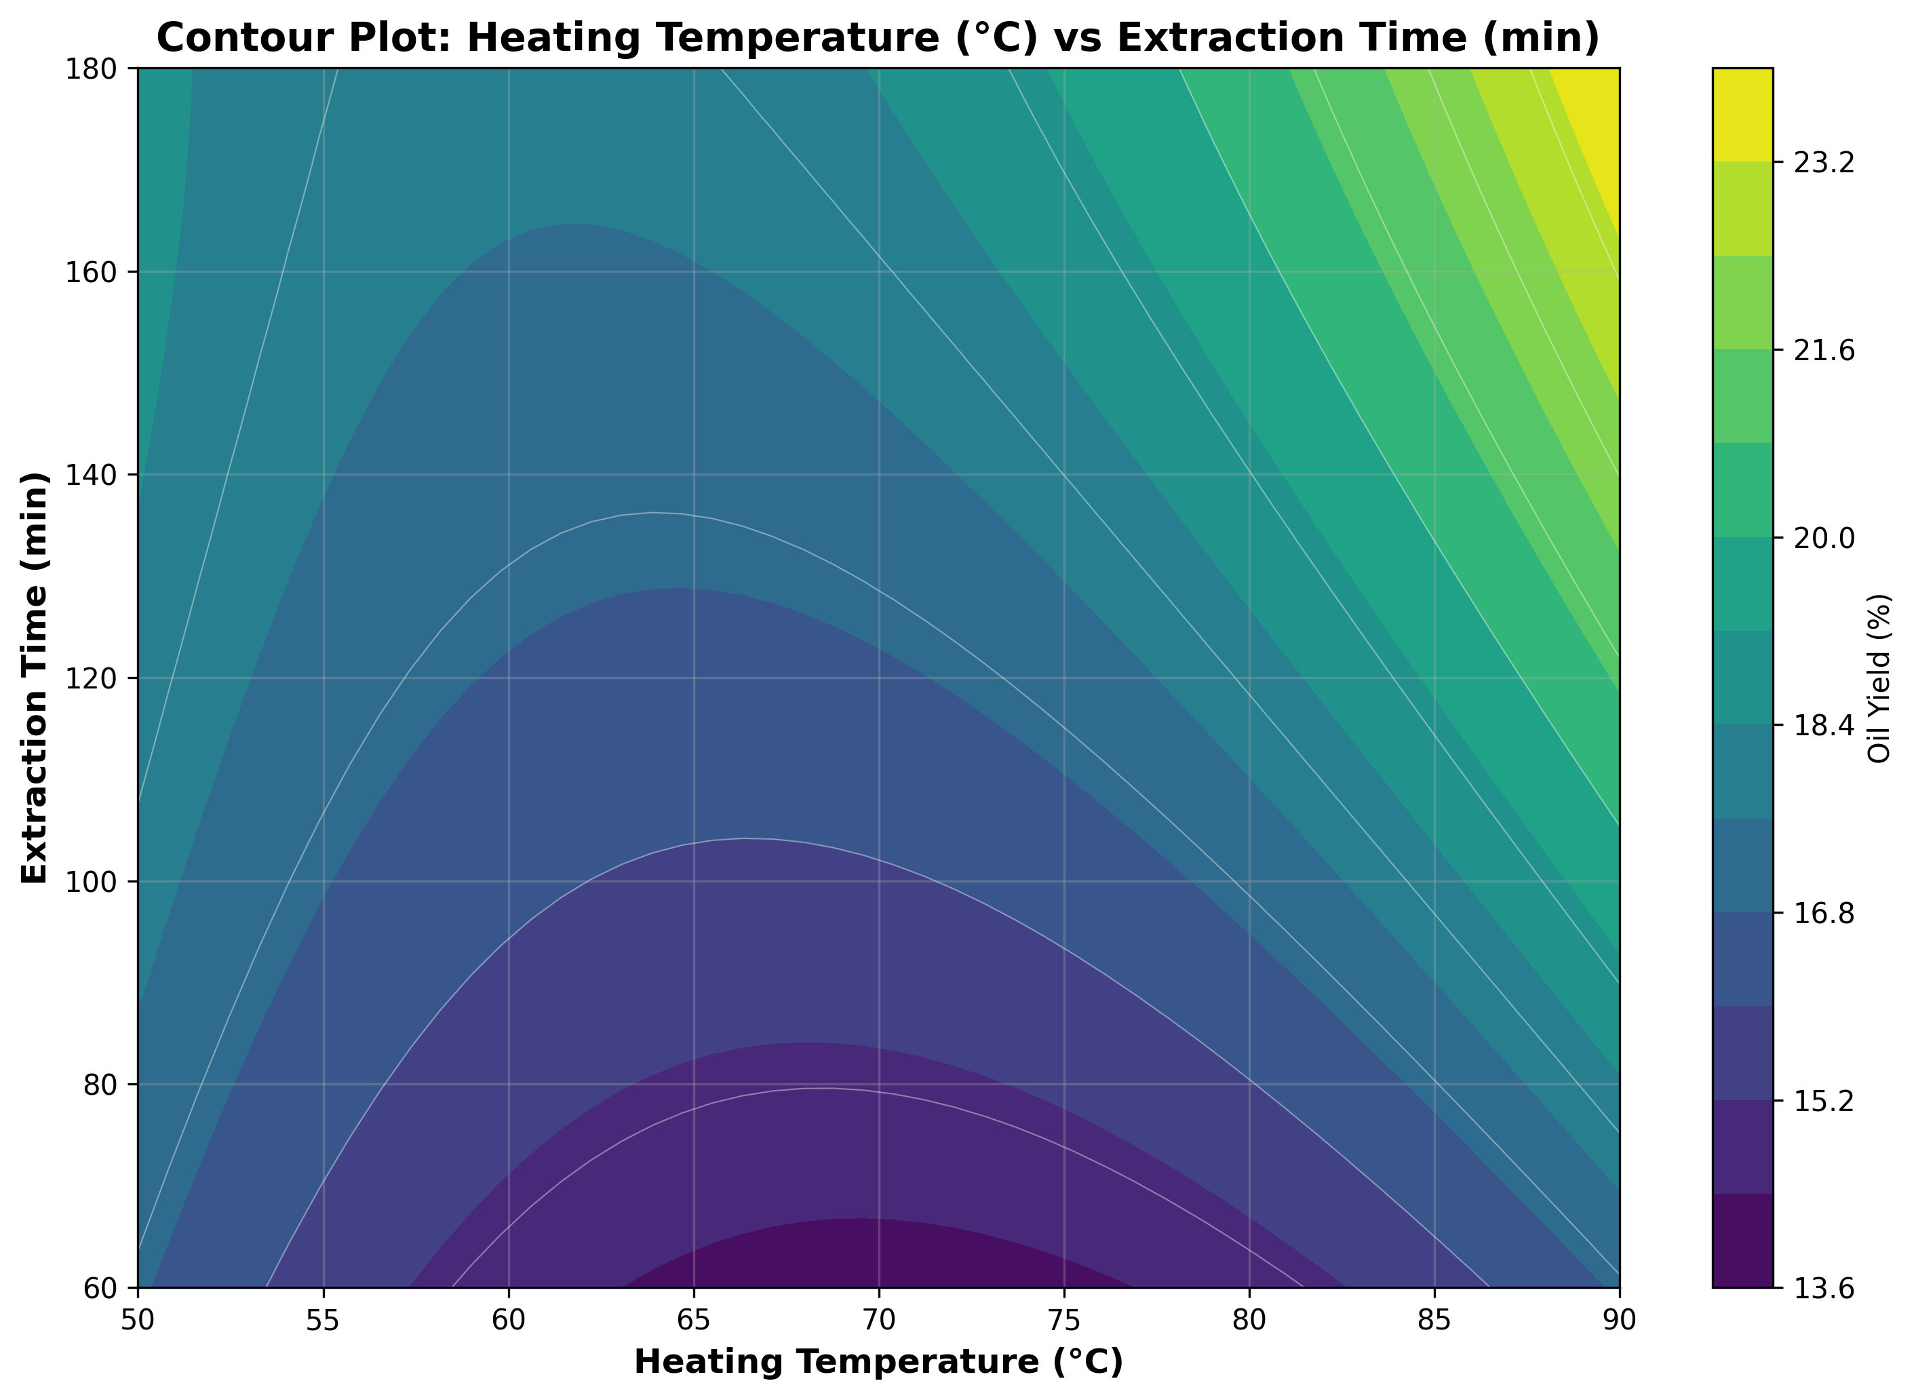

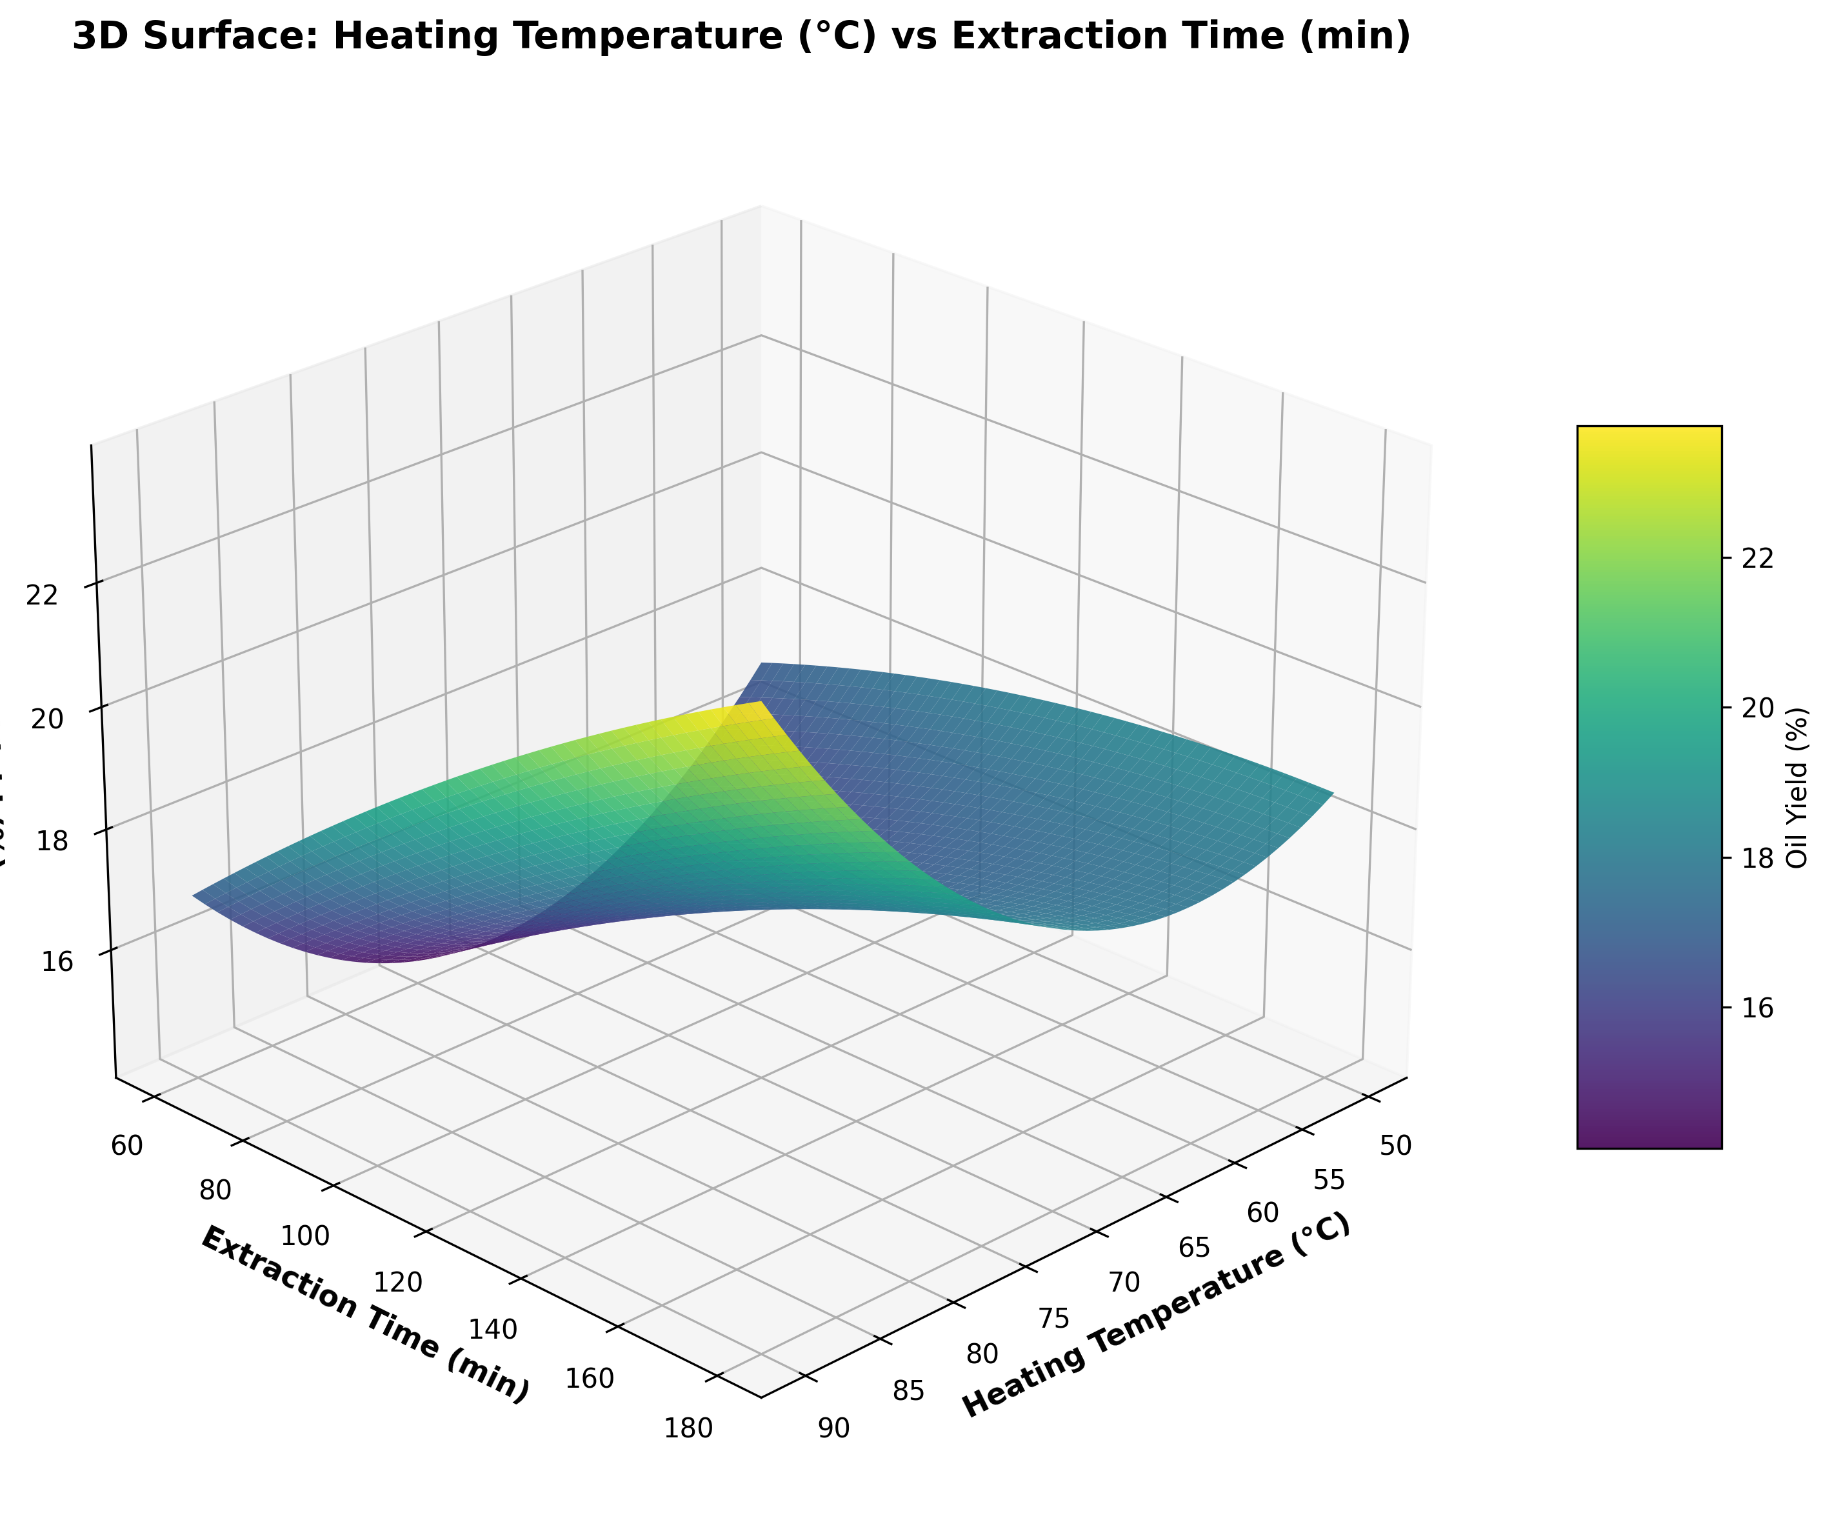

## 4.4 Heating Time (min) vs Extraction Time (min)

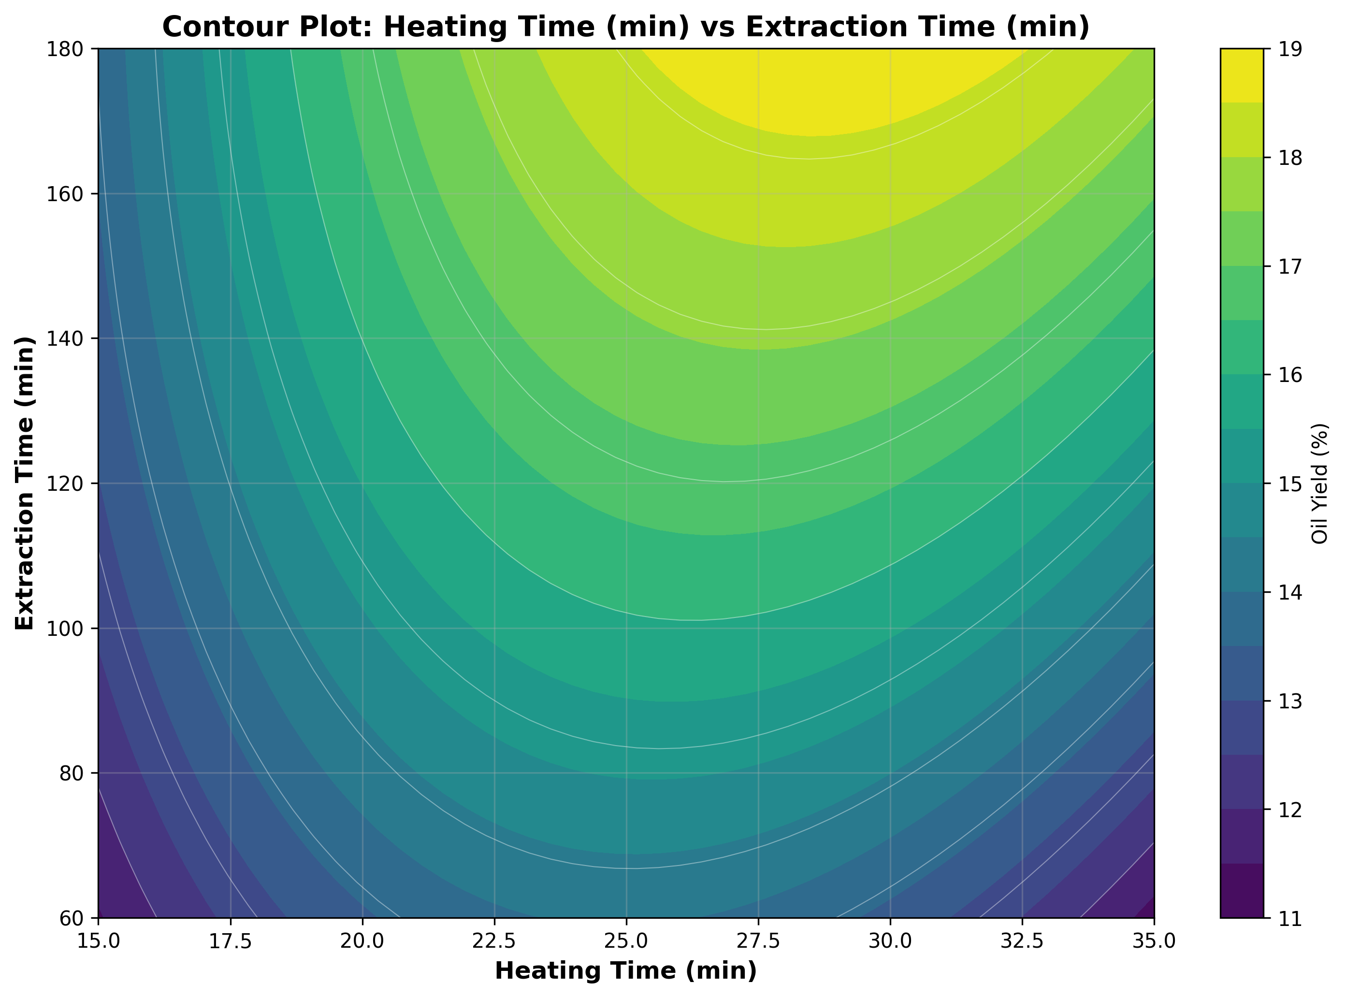

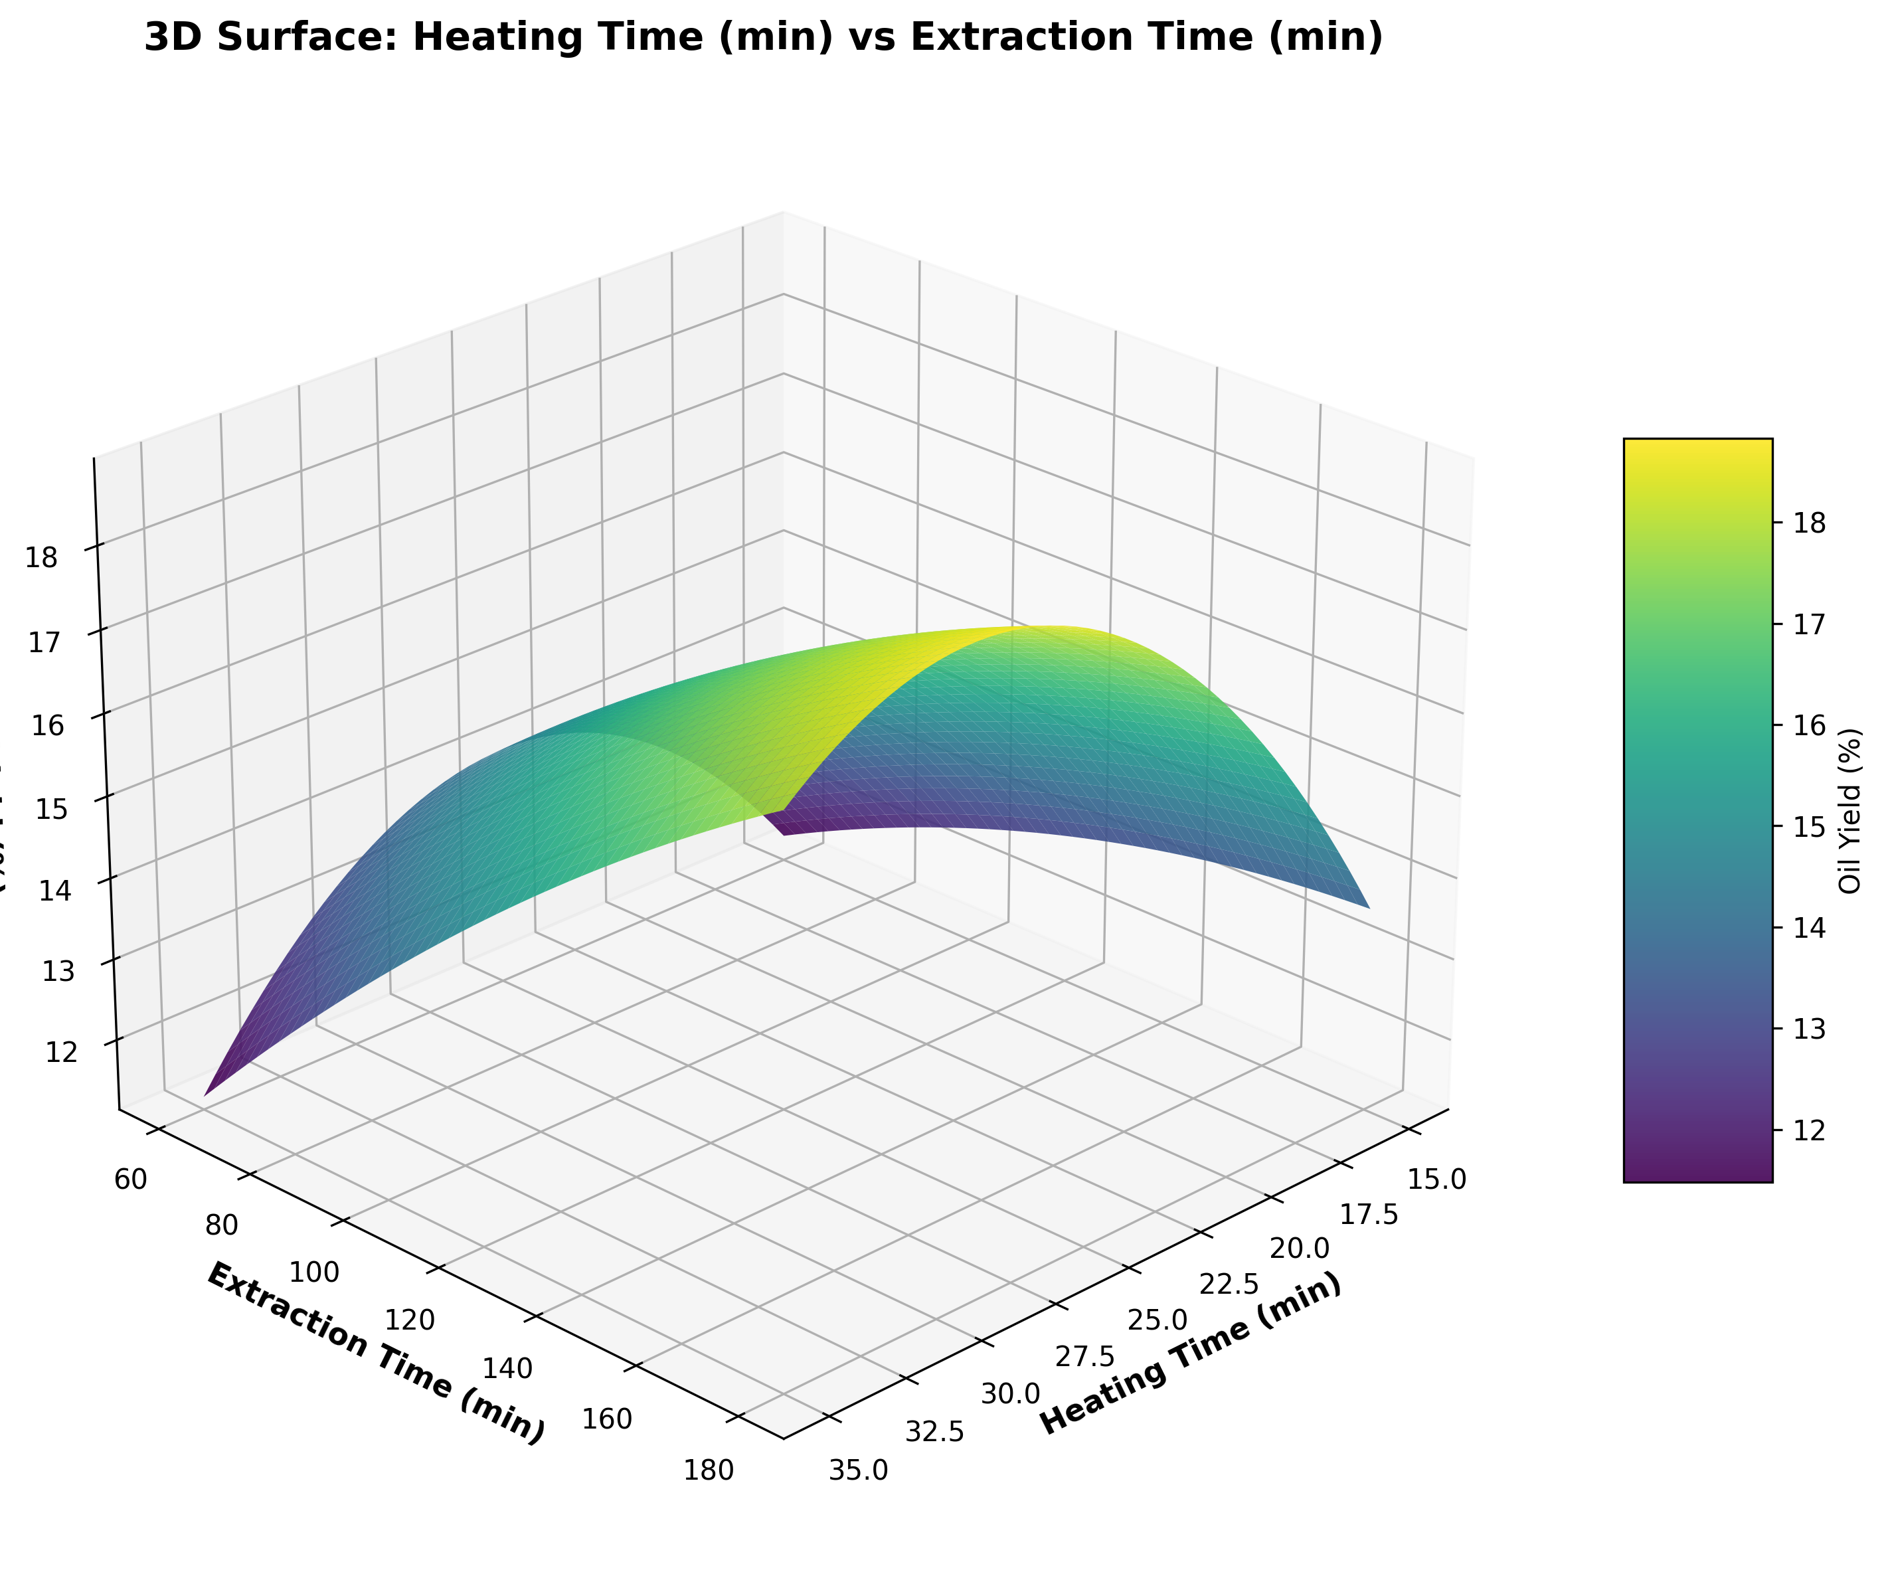

# 5. Optimization Results

Optimal Process Parameters (from optimization):

• Moisture Content: 6.00 %

• Heating Temperature: 90.00 °C

• Heating Time: 35.00 min

• Extraction Time: 180.00 min

• Predicted Maximum Oil Yield: 37.92 %

Comparison with Experimental Maximum:

• Experimental maximum oil yield: 26.70% (Run 28)

• Experimental conditions: MC=12%, HT=90°C, Ht=30min, SET=180min

• Optimization prediction: 37.92%

• Difference: 11.22%

# 6. Regression Model Equation

Oil Yield (%) =

0.0000 - 1.0142*X1 + 0.6725*X2 + 0.5125*X3 + 1.0967*X4 - 0.1787*X1^2 + 0.2788*X1 X2 - 1.4000*X1 X3 -

1.6900*X1 X4 + 0.7113*X2^2 + 0.4875*X2 X3 + 0.3350*X2 X4 - 0.6725*X3^2 + 0.2763*X3 X4 - 0.1112*X4^2